# Guidance for Staff on Updating Your Equality Information in People & Money

Within People & Money, you are able to update your equality information at any time. Your equality information is held in two separate areas in People & Money: these areas are titled ‘Personal Details’ and ‘Additional Person Info’.

You can update the following personal details: Disability, Ethnicity, Gender* and Gender Identity, Marital/Civil Partnership Status, Sexual Orientation, and Religion or Belief.

You will receive a notification (by email and in People & Money) to confirm any changes that you have made. Some changes that you make will result in a ‘pending approval’ message this is system approval only, your line manager will not be sent notification of your changes. You will need to sign out and back in again to see the changes in your record.

*Essential information for non-UK/Irish staff making changes to these details can be found at the end of this document.

## Disability Changes

Within People and Money, we use the term ‘HESA Disability’ to harmonise our data reporting to the Higher Education Statistics Agency (HESA). You can record up to four types of disability from the drop down lists under the titles ‘HESA Disability 1 - 4’.

**System steps for Disability changes:**

Go to Me > Personal Details > Biographical Info

To edit this information click on the **pencil icon** at the right hand side of the Biographical Info box.

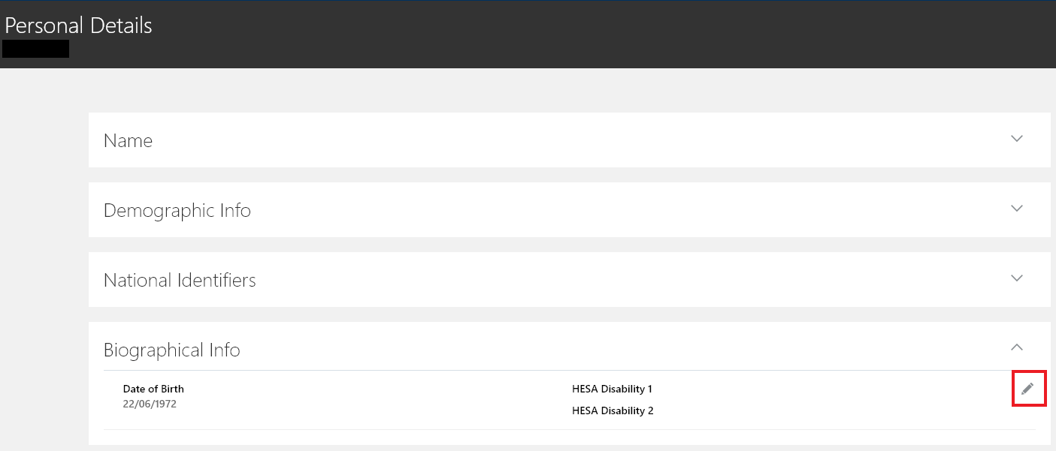

To edit the information within ‘HESA Disability 1-4’, choose from the drop down list.

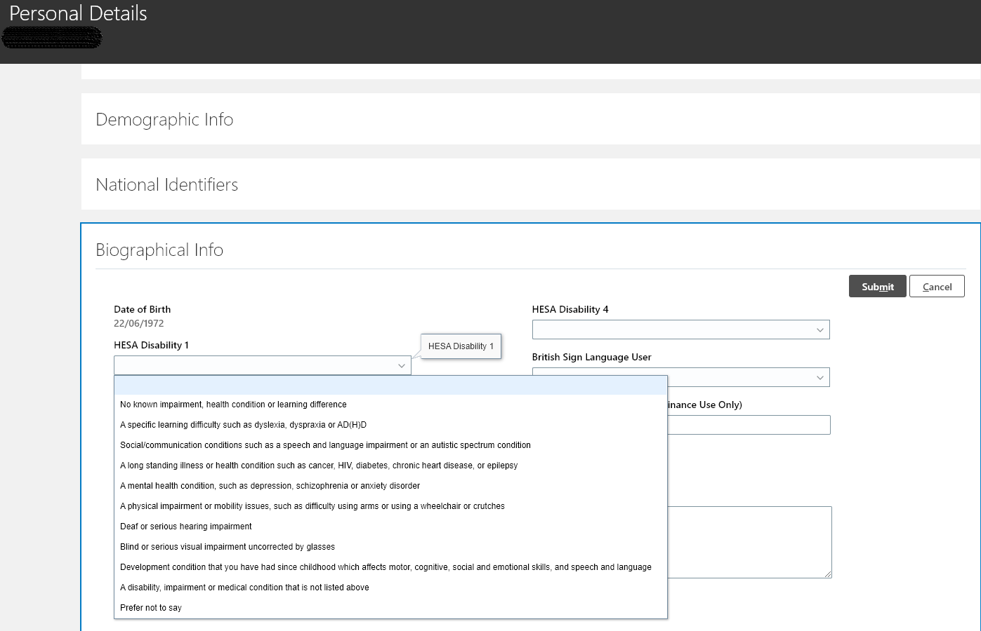

Where appropriate, follow the same steps for adding disabilities under ‘HESA Disability 2, 3 & 4’.

Once you have made your changes, click **Submit**.

## Ethnicity Changes

**System steps for Ethnicity changes:**

Go to Me > Personal Details

To edit this information click on the **pencil icon** at the right hand side of the Demographic Info box.

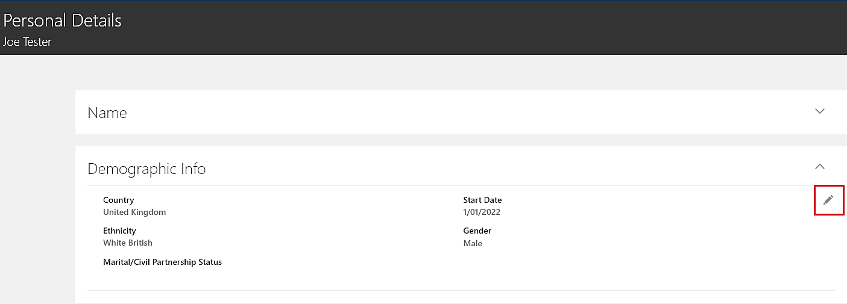

To edit your Ethnicity, choose from the drop down list.

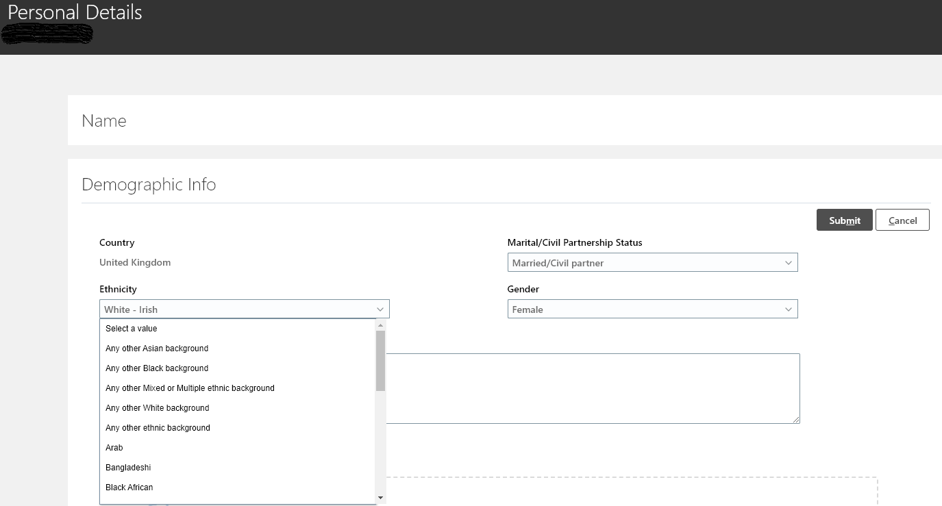

Once you have made your changes, click **Submit**.

## Gender and Gender Identity Changes

We recognise that the term ‘gender’ means different things to different people. Within People & Money, the field titled Gender is used for mandatory reporting to HMRC, and the field name reflects the terminology used by HMRC. You are able to record either ‘male’ or ‘female’ in this field, and leaving it blank is not permitted.

You are able to record gender beyond these binary options within the field titled Gender Identity.

**System steps for Gender changes:**

Go to Me > Personal Details

To edit this information click on the **pencil icon** at the right hand side of the Demographic Info box.



To edit your Gender choose from the drop down list.

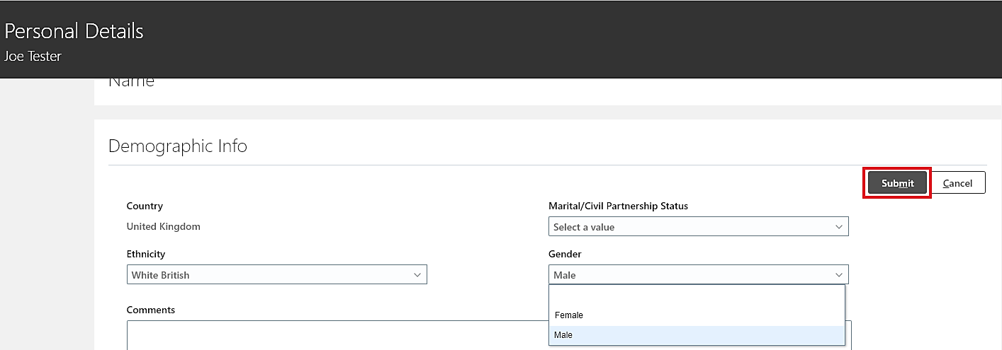

Once you have made your changes, click **Submit**.

**System steps for Gender Identity changes:**

Go to Me > Additional Person Info > Protected Characteristics

To edit this information click on the **pencil icon** at the right hand side of the Protected Characteristics box.

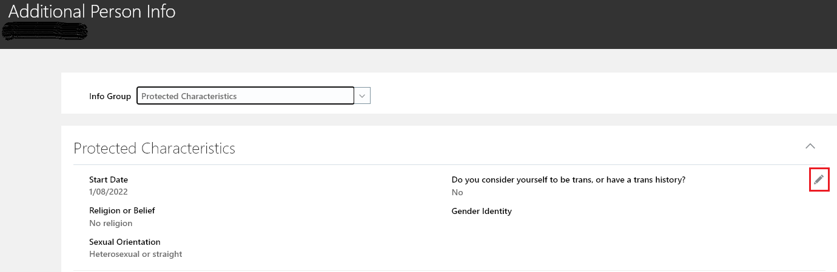

To edit your Gender Identity, choose from the drop down list.

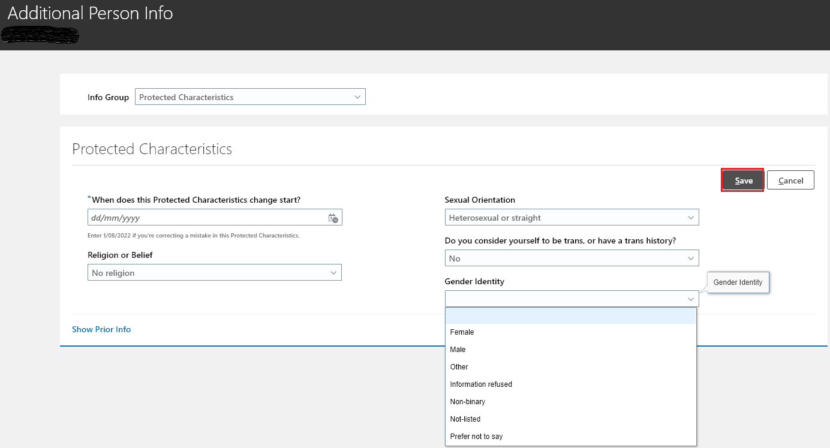

Once you have made your changes, click **Save**.

To note if you consider yourself to be trans or have a trans history, choose from the drop down list.

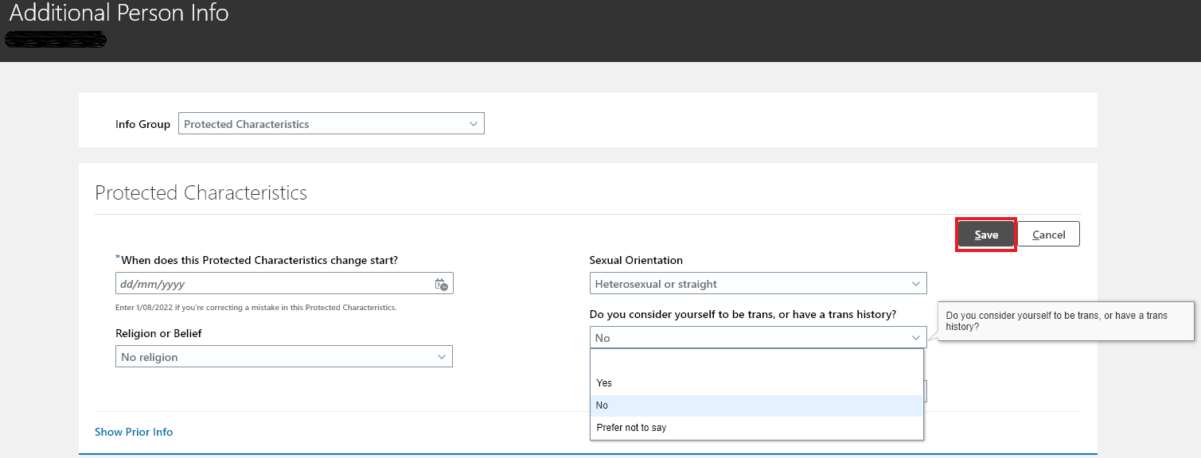

Once you have made your changes, click **Save**.

## Marital/ Civil Partnership Status Changes

You can change your marital/ civil partnership status in People & Money without documentary evidence. You may choose to notify HMRC and your pension provider(s) of the change to your marital/civil partnership status, in order to take advantage of any associated benefits.

**System steps for Marital/ Civil Partnership Status changes:**

Go to Me > Personal Details

To edit this information click on the **pencil icon** at the right hand side of the Demographic Info box.



To edit your Marital/Civil Partnership Status, choose from the drop down list.

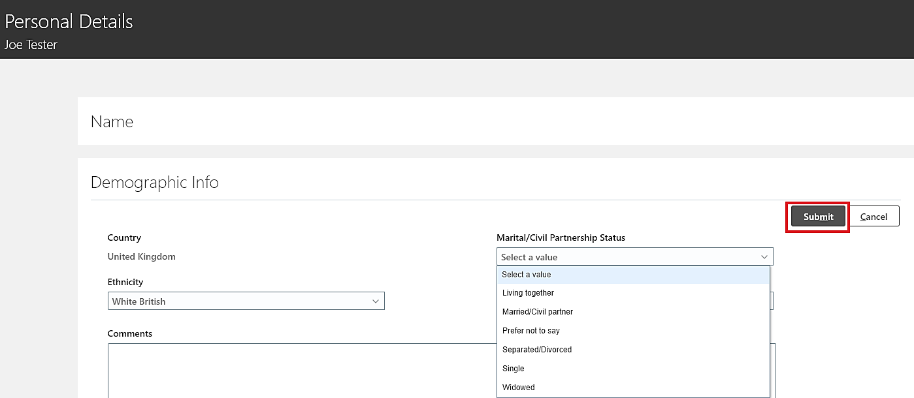

Once you have made your changes, click **Submit**.

## Religion or Belief Changes

**System steps for Religion or Belief changes:**

Go to Me > Additional Person Info > Protected Characteristics

To edit this information click on the **pencil icon** at the right hand side of the Protected Characteristics box.



To edit your Religion or Belief choose from the drop down menu.

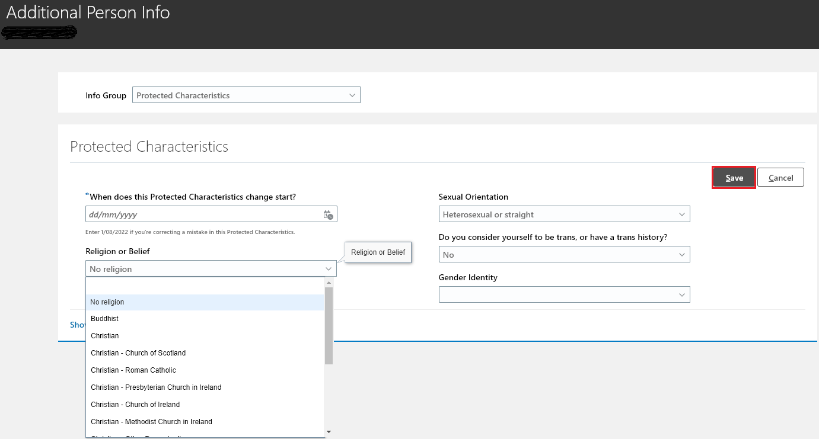

Once you have made your changes, click **Save**.

## Sexual Orientation Changes

**System steps for Sexual Orientation changes:**

Go to Me > Additional Person Info > Protected Characteristics

To edit this information click on the **pencil icon** at the right hand side of the Protected Characteristics box.



To edit your Sexual Orientation choose from the drop down list.

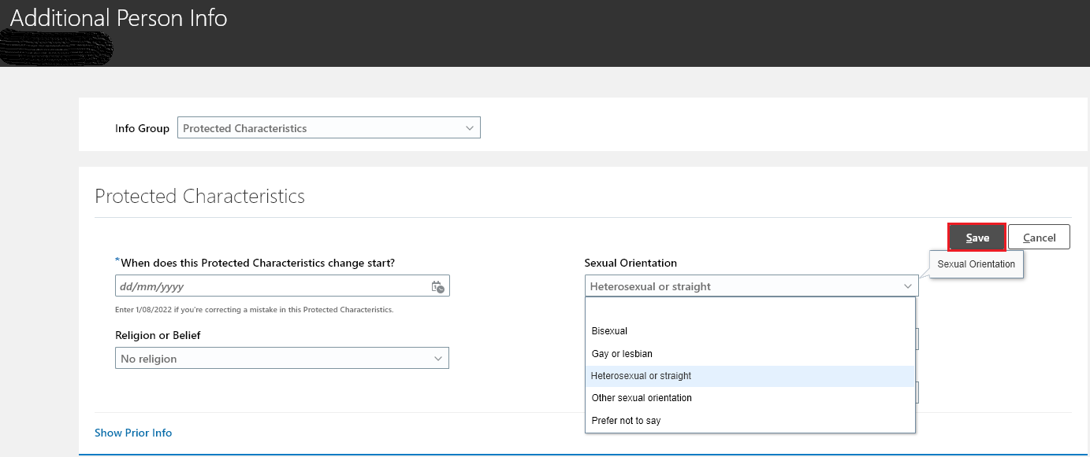

Once you have made your changes, click **Save**.

## Non-UK Staff with a visa

If you are making any changes to your name and gender details in the People & Money system, you should also update your details on your UK Visas and Immigration (UKVI) account. If your UKVI account is out of date you might experience delays when you travel, when proving your immigration status or when waiting for a visa decision.

Staff who hold visas can find more information on setting up their UKVI account, eVisa access and the requirements of updating their account at the [UK Government website.](https://www.gov.uk/evisa)

Staff with EU settlement status can find more information on this at the [UK Government website](https://www.gov.uk/settled-status-eu-citizens-families).

If you have a time-limited right-to-work (RTW) and you make any changes to your name and gender details, and your eVisa is in a different name to the one you wish to be known as, you must be able to explain and provide documentary evidence to explain the discrepancy and to show that you are known by the name given. Examples include a birth certificate, marriage certificate or civil partnership certificate, change of name deed or other official documents.

If you require this document in an alternative format, such as large print or a coloured background, please contact: [Equalitydiversity@ed.ac.uk](mailto:Equalitydiversity@ed.ac.uk) .