Table of Contents

Overview 2

Guides 6

7

Recruitment Managers 7

10

Principles for Shadowers 10

Guides and Tips 14

Post-Interview Shadowing Guidelines 15

Shadowing Reflections 15

Broadening Leadership 16

*Role Simulation Exercise* 17

Personal & Professional Development 18

*Learning new skills.* 18

*Self-Development* 18

Networking and your Personal Brand 19



# Overview

These principles are designed to support enriching development opportunities to those seeking progression to higher grades or wanting to improve their interview skills. By enabling colleagues to shadow interview panels for more senior roles, this initiative supports the University's commitment to grow our internal talent and diversify our staff. While these principles were conceived to improve representation at grade 8 and above, these principles can benefit colleagues seeking progression to the next grade or into a different role.

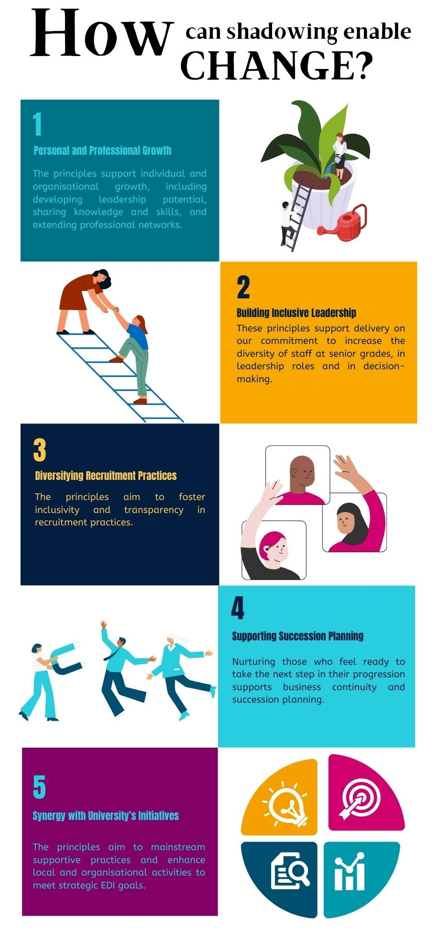

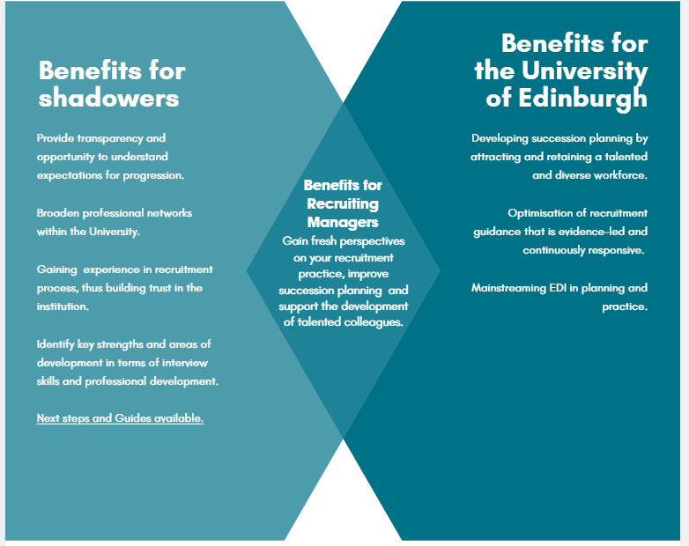

# Guides

**The guides below set out principles and tips for Recruiting Managers and Shadowers.**



### 

### Recruitment Managers

Thank you for taking the time to invite an aspiring colleague to shadow your interview(s). Your commitment to provide enriching learning opportunities supports the University's commitments to our staff and will be an interesting experience for you as well.

Finding a Shadower

* Consider whether the position you are recruiting for may be of interest to a potential Shadower. You may particularly wish to consider Shadowers from underrepresented groups and/or those who have been unsuccessful in previous interviews for roles at this grade.
* You’ll need to identify those who are interested in shadowing opportunities. This could be through Annual Reviews or a School/Department register of interest which we’d recommend as the simplest way to connect Shadowers to shadowing opportunities.

Pre-interview

**Briefing your Shadower in preparation for interview observation**.

Whilst the Shadower is not a formal member of the panel, it may be useful for them to read the [Recruitment Guidance](https://www.ed.ac.uk/human-resources/recruitment-guidance/defining-and-advertising-the-role) and [Diversifying Recruitment](https://equality-diversity.ed.ac.uk/inclusion/diversifying-recruitment) documents in preparation for shadowing the interview panel.

1. Engage in an honest discussion about their interview experience. The opportunity to observe different approaches in delivering interview tasks and answers will advance their own approach to interview technique.
2. Explain the essential and desirable criteria, the questions you will ask, and the types of evidence you are looking for from the candidates
3. Take the opportunity to get a fresh perspective on your planned approach, they might help you recognise any potential barriers for candidates you may have missed.
4. Discuss if the Shadower is comfortable introducing themselves to the candidate. Consider using the following statement:

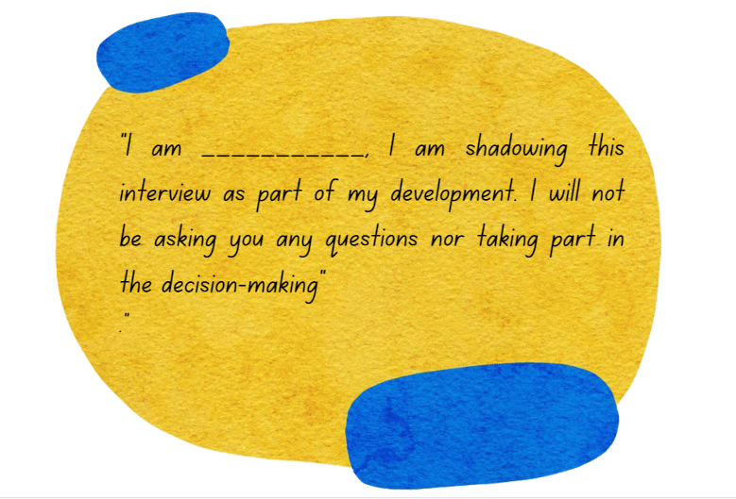

Interview and Panel discussions

1. The Shadower may introduce themselves or will be introduced by you.
2. Conduct the interview as agreed with the formal panel.
3. The Shadower will not take part in the recruitment decision-making. However, listening to the panel discussions will help them to understand what evidence the panel is looking for to best satisfy the role criteria.

After the interview

**Next steps to aid Shadowers in their development journey**

1. Take the opportunity to openly discuss the Shadower’s experience of the recruitment panel to inform the development of your own practice and answer any questions that they may have about the process, their learning and observations.
2. Encourage your Shadower to identify their development needs and opportunities that will support their career progression, and to include these in their Annual Reviews and other development conversations with their manager.
3. Where feasible and appropriate, you may be able to help connect your Shadower with further learning, development and networking opportunities.

[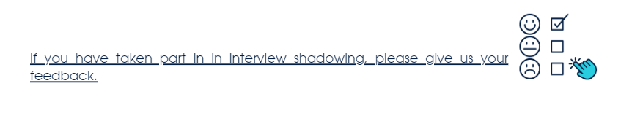](https://uoe.sharepoint.com/sites/EDITeam/Shared%20Documents/General/Projects/Diversifying%20Recruitment%202.0/Interview%20Shadowing/sAafLmkWiUWHiRCgaTTcYTHa_yR0g5pGu_OmD_7GtDNUQ1VaNUJENFJTR1FESkxIVkdRMk9HRkRUWC4u)

### 

### Principles for Shadowers

Background

Interview shadowing at the University of Edinburgh is designed to provide enriching learning opportunities and supports the University's commitment to grow our internal talent and to diversify staff at senior grades, in leadership roles and in decision-making.

Key benefits for Shadowers.

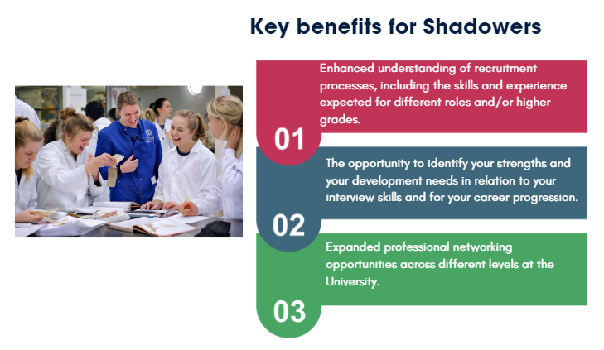

Communicating your interest and reflecting on your learning objectives.



1. Communicate your interest during your Annual Review and/or through School/Department development mechanisms, where available.
2. Research advertised roles at the university to understand the essential and desirable criteria of the roles you seek. If you want progression to a higher grade, the [University Grade Profiles](https://www.ed.ac.uk/files/atoms/files/grade-profiles_updated_august_2018_v.6.pdf) can help you to identify the skills and experience you can already demonstrate and those that you may need to develop.
3. If there are any specific jobs you are interested within your School or Department, don’t be afraid to contact the Recruiting Manager and ask for more information about the role and the potential to either shadow or apply.

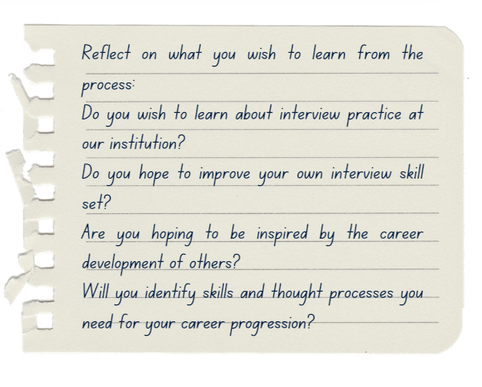

Pre-Interview

1. Engage in an honest conversation about what your goals and hopes are for this process.
2. Ask any questions you may have about the desirable and essential criteria, the questions that the candidate will be asked, and the types of evidence the panel will expect to see demonstrated.
3. Take the opportunity to share your fresh perspective on the planned approach, such as any potential barriers for candidates that you may identify.
4. Discuss how you wish to be introduced to the candidate. Consider using the following statement:



During the interview and panel discussions

1. If appropriate and agreed with the Recruiting Manager, you should introduce yourself, or they can do it for you.
2. Observe the interview as agreed with the panel.
3. As a Shadower, you will not be part of the recruitment decision-making. However, listening to the panel discussions will help you to understand what evidence the panel is looking for to best satisfy the role criteria.

After the interview

**Next steps to aid your development journey**

1. Take the opportunity to discuss your experience of the interview process with the Recruiting Manager. How has this informed your own interview practice? What aspects have you found of interest? Do you have any questions about the process?
2. Reflect on the skills and experience required for the role you aspire to and identify the actionable opportunities that support your career progression and include these in your Annual Reviews and other development conversations.
3. If feasible and appropriate, you may want to develop your learning and networking with members of the panel or ask members to connect you with their own networks.
4. Sharing interview good practice with other aspiring colleagues is encouraged, however, we ask you to keep confidential the names of candidates and panel members.

[](https://uoe.sharepoint.com/sites/EDITeam/Shared%20Documents/General/Projects/Diversifying%20Recruitment%202.0/Interview%20Shadowing/sAafLmkWiUWHiRCgaTTcYTHa_yR0g5pGu_OmD_7GtDNUQ1VaNUJENFJTR1FESkxIVkdRMk9HRkRUWC4u)

Next steps

Observing an interview process will have given you plenty of food for thought. The following tips are designed to guide your next steps.

# Guides and Tips

**Shadowing Reflections**

Reflect on top candidates' delivery and compare to your own approach.

**Role Simulation Exercise**

Prepare interview answers from the perspective of applying for the role yourself.

**Broaden Leadership Understanding**

Rethink your definition of leader as someone who manages others. We all have the scope to become leaders.

**Personal & Professional Development**

Focus on identifying and developing the necessary skills for career progression.

**Networking and your Personal Brand**

Leverage new contacts for advice and potentially establish mentorship relationships to enhance your personal brand.



# Post-Interview Shadowing Guidelines

### Shadowing Reflections

Reflect on top candidates’ delivery and compare to your own approach.

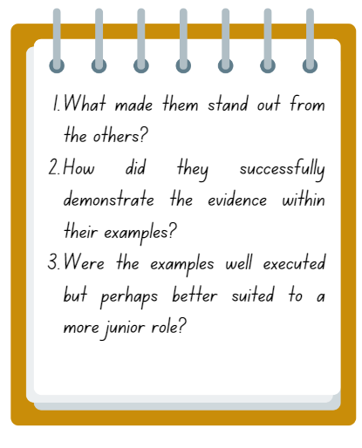Understanding the scoring criteria and the level of detail required to demonstrate abilities and competencies at interview, will give you the confidence to dissect candidate’s responses and apply to your own interview practice. With the successful candidate in mind, answer these questions:

Evaluating candidate’s performance

Whilst you will not formally give any feedback to the candidates, it is a very useful exercise for you to write down a few notes on your own evaluation of candidates’ performance and see how those compare to the panel’s. Do any of these observations resonate with your own interview skill set?

Your response to the above questions will undoubtedly offer you specific pointers to improve your interview skills (i.e. effective communication, choosing relevant examples, polishing tone, and conveying expertise, etc). However, it is also valuable to critically evaluate the skills and experience that you are yet to acquire.

### Broadening Leadership

Leadership is defined by your actions, not by your position. A leader sees how things can be improved and inspires and motivates people to move toward that vision.

Who is a leader?

When applying for more senior roles, you may feel intimidated when comparing your experience to that of others. Especially if you traditionally view a leader as someone who manages other people. The University encourages all colleagues to adopt the [behaviour charter](https://www.ed.ac.uk/files/atoms/files/behaviours_charter_22_january_2021.pdf) and "strive to continuously improve our work while aiming to deliver the best way that we can." This aligns with the broader [definition of leadership](https://brenebrown.com/hubs/dare-to-lead/#:~:text=1%20of%202-,A%20leader%20is%20anyone%20who%20takes%20responsibility%20for%20finding%20the,there%2C%20and%20lean%20into%20courage.):

**"Anyone who takes responsibility for finding the potential in people and processes, and who has the courage to develop that potential."**

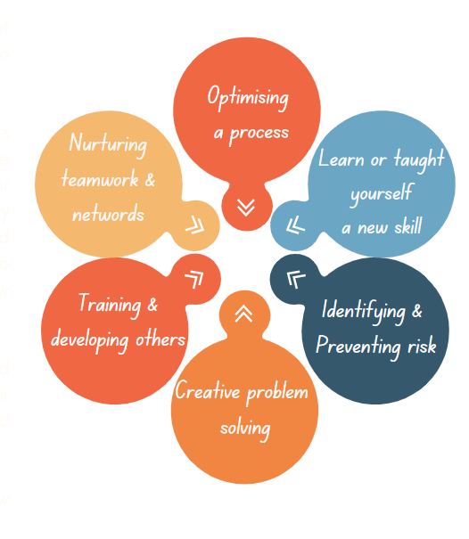This definition emphasises that leadership is not about titles or seniority; rather, it's about striving to optimise our work and finding innovative solutions.

Recognising yourself as a leader under this definition can be transformative. Looking at the graphic to the right, think of examples from your paid and/or volunteering positions where you may have gone beyond the scope of your role and developed solutions or found new ways to approach a problem. You will be surprised at how many leadership qualities you already possess.

Highlighting the leadership skills you possess and identifying the ones you need to acquire for your desired goal will make you more driven and resolute in your career journey.

The following pages have more suggestions on how to make the most of observing an interview.

### Role Simulation Exercise

Prepare interview answers from the perspective of applying for the role yourself. This will nudge you to think of your current skillset and experience in a more aspirational light, thus highlighting any aspects you are yet to develop.

Reviewing your skill set

Whilst it might be intimidating to compare your experience to that of more senior candidates, remember your motivations of engaging in this process and challenge your traditional leadership concepts. Oftentimes, we identify leaders as those that manager others and may disregard existing leadership qualities that we have at our disposal, for instance, the ability to identify and pre-empt risks, or the drive to improve processes so that the whole team works more efficiently.

Once you have reviewed your answers, read them critically whilst thinking about the following questions:



### Personal & Professional Development

### Learning new skills.

Focus on identifying and developing the necessary skills for career progression. Discuss your development with your manager and engage with opportunities for growth.

Observing an interview process and its corresponding scoring will undoubtedly have given you a sharp focus on how to best to present your unique skills set. To move to the next grade and/or to continue progressing your career, it is important that you identify the skills that you need. If you are unsure, don’t be afraid to ask for help by engaging in the following:

### Self-Development

It helps to know exactly the type of skills you need for your next position as this will make your next steps more effective. When looking at positions you are interested in, look closely at the essential criteria and the skills that it requires. How does your skill set compare? Are you able to engage in stretching assignments or projects at work that will give you tangible experience in this skill set? Does any of your network have opportunities for growth? Could you volunteer to gain a transferable experience?

Discuss with your manager the transferable skills that are beneficial for your career/current position and discuss creatively the stretching tasks that you could engage in.

Some colleagues might feel uncomfortable discussing with their manager how to acquire skills for their next position. Ensure your work, projects and outputs demonstrate your commitment to your current role as this will instil confidence in your manager to trust you with stretching assignments or connecting you with the colleagues that might be able to help you. In addition you may want to discuss the [360 Degree Feedback](https://www.ed.ac.uk/human-resources/learning-development/courses/psychometrics-and-feedback-tools/360-degree-feedback) Development tool, with your line Manager.

Gaining experience

Sometimes we might get hyper-focused on getting a ‘like for like’ stretching experience. Think about any similarities between your existing role first and the desirable criteria of your next role. Is there scope for you to gain these skills in your existing team or will you have to look beyond your team?

Learning transferable skills

### Career paths are rarely linear. Try to think strategically and consider both your commitments in and outwith your current role and looks for the skills and experience rather than the actual tasks – this will help you find transferable knowledge.

### Networking and your Personal Brand

Leverage new contacts for advice and establish a network to enhance your personal brand.

Networking

Make the most of the contacts you have just made and ask them about their career, their own progression and use their experience to guide your career development. Careers are rarely linear and you are likely to get a lot of inspiration.

Mentoring

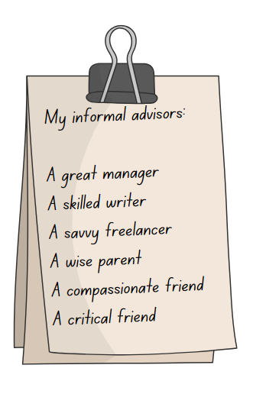You might ask a more senior colleague to be your mentor. Traditionally a mentorship involves following the path of a senior colleague you admire. This one-to-one relationship has the potential for gaining new skills and experience that will shape your personal brand. To learn more on approaching a mentor and nurturing this relationship, please read this [article.](https://hbr.org/2021/03/whats-the-right-way-to-find-a-mentor)

#### *An informal group of advisors: Learning specific skills from your growing network*

As you continue developing your skill set in preparation for your next role. You will become more self-reflective and assertive in finding and addressing the specific skills that you are yet to acquire. Our suggestion is to build an informal group of career advisors. These friends or friendly colleagues may help you develop diverse angles of your personal brand by bringing a specific expertise to the table.

You may ask one of the interview panelists to let you shadow a project or collaborate. Perhaps you already know someone who has a persuasive communication style you wish to learn. It is imperative that you also identify someone that can serve as a critical friend. Your personal branding and development deserve attention, and you are the best person to manage this magnificent project. Click here to read more about this concept please read this article on the Harvard Business Review.